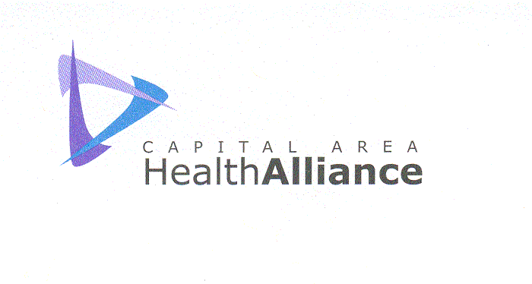

MEDIA ADVISORY Contact: Valerie Glesnes-Anderson
For Immediate Release Telephone: 517.347.3377
Thursday, October 18, 2012 E-mail:CAHealthalliance@aol.com

Choosing Health!® Rally
Sunday, October 21, 2012
Local Businesses, Schools, Governments, Healthcare and Social Agencies Sponsoring Effort to Promote Healthy Lifestyles at Greater Lansing’s Largest Healthy Lifestyles Rally, with nationally known nutrition speaker Zonya Foco

WHY: We are dealing with significant health problems in the Capital Area. In Clinton, Eaton and Ingham Counties, 31-32% of the population struggles with obesity, 22-26% of our population is inactive and 18% engage in excessive drinking. The Capital Area Health Alliance and its resource partners have begun a campaign called Choosing Health!® designed to help members of Mid-Michigan’s Capital Area learn about existing programs to achieve healthy lifestyle goals. Over 90 businesses and organizations have joined this movement and on October 21, 2012, we are having the Fall/Winter Choosing Health!® Rally to get the community moving and eating right! This event is supported in part by a generous contributions by the Capital Region Community Foundation, Lansing Community College, Nexcare Health Systems, CATA, The Capital Area Health Alliance, Capital Area United Way, Ingham County Health Department, Michigan Department of Community Health and the Lansing School District.

WHO: Over 30 organizations, businesses and agencies will have displays to show area residents resources to help with their healthy lifestyles quest for the fall and winter. Local caterers and restaurants will have free healthy food samples for a “Taste of Health” and fitness professionals will offer demo classes on ways to stay active. This event is totally FREE.

WHAT: The Capital Area Health Alliance, Healthy Lifestyles Committee is hosting a FREE community-wide Fall/Winter Choosing Health! Rally to encourage Capital Area residents to become more physically active, develop healthy eating habits, prevent substance and tobacco abuse and promote mental health. There will be door prize drawings, healthy living displays from area programs and retailers, free nutritious food samples from area restaurants and businesses, free demo classes, and a free presentation by nationally known, and seen on PBS, nutritionist Zonya Foco, introduced by Ingham County Health Officer Dr. Renee Canady. Plus, an opportunity to learn more about Governor Snyder’s 4x4 Plan to improve health and wellness in our community.

WHEN: 2:00 – 4:30 PM
Sunday, October 21, 2012

WHE WHERE: Pattengill Academy
626 Marshall Street
Lansing, MI 48912

MORE INFO: Visit CapitalAreaHealthAlliance.org. CAHA is a non-profit organization that formed in 1994 to empower the tri-county community to achieve better health. The Alliance has grown to include over 170 organizations in the Greater Lansing Area, including health professionals, community organizations and businesses.

###

